**Step 1 :** **Create a New Job by name “webapp-pipeline”**

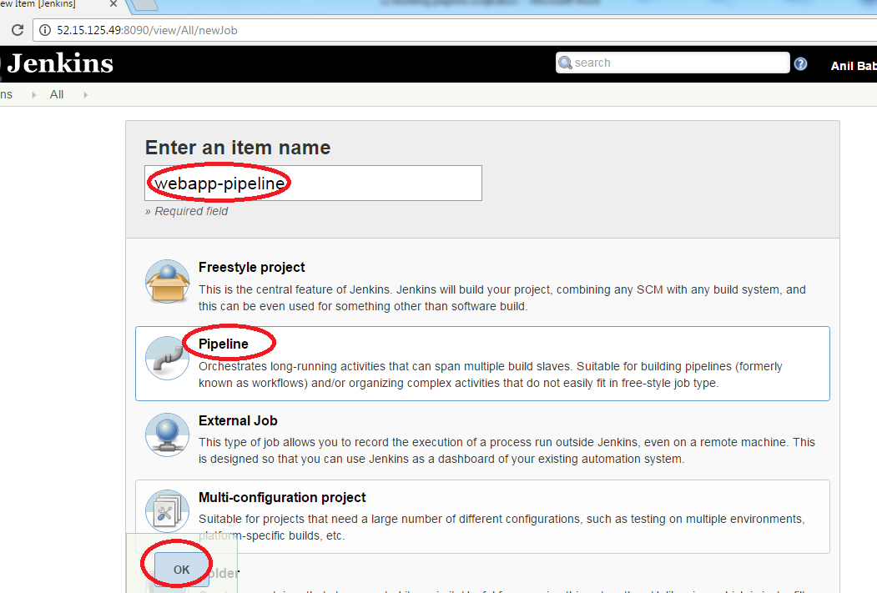

**Next step :** **Click on “pipeline”**

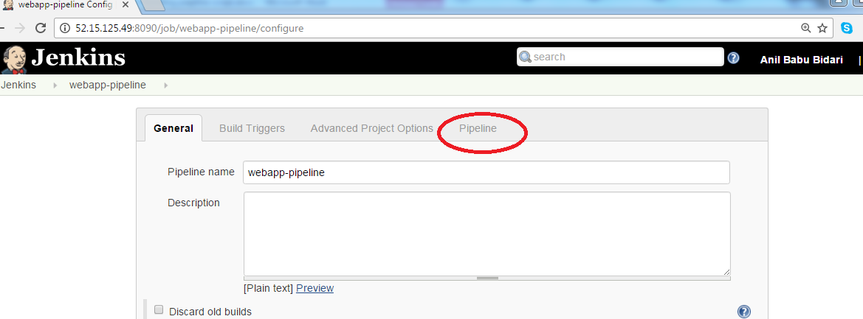

**Next step :** **key in this below content**

git 'https://github.com/anilbidari/https-github.com-g0t4-jenkins2-course-spring-boot.git'

dir('spring-boot-samples/spring-boot-sample-web-static/')

{

stage 'compile,test and package'

sh 'mvn clean package'

archiveArtifacts 'target/*.jar'

sh 'java -jar target/spring-boot-sample-web-static-1.4.0.BUILD-SNAPSHOT.jar'

}

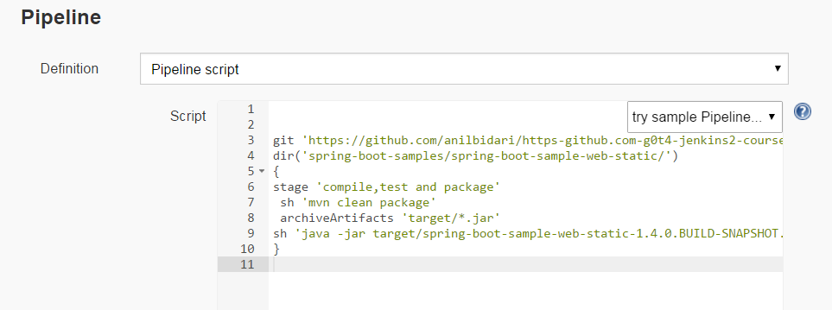

**Next step :** **Click on build now**

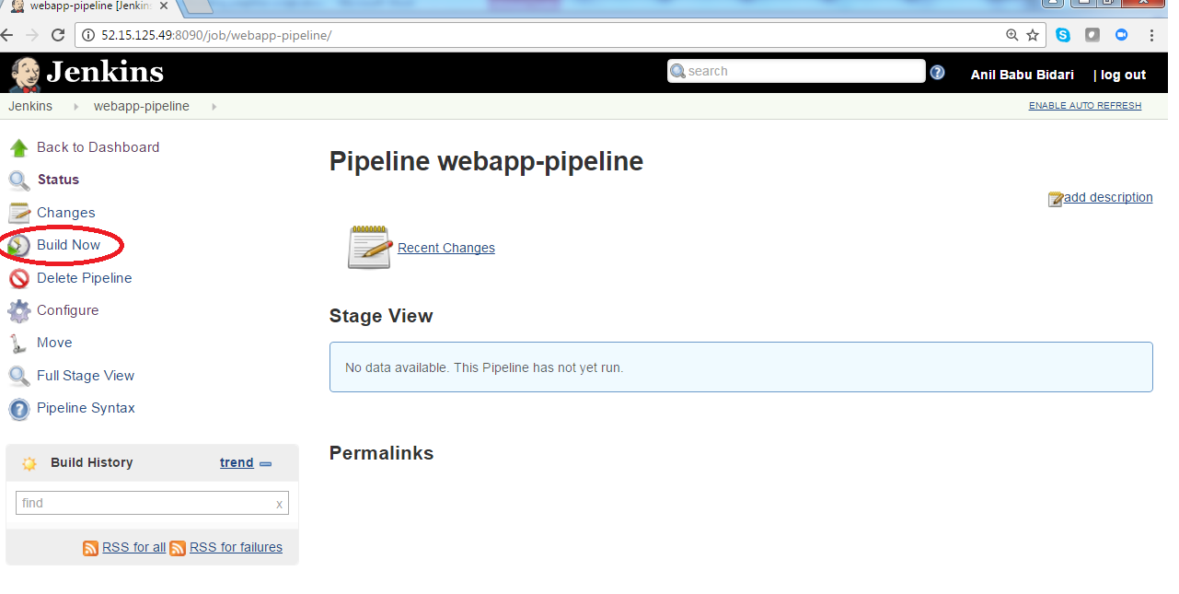

**Next step :** **Click on build #1**

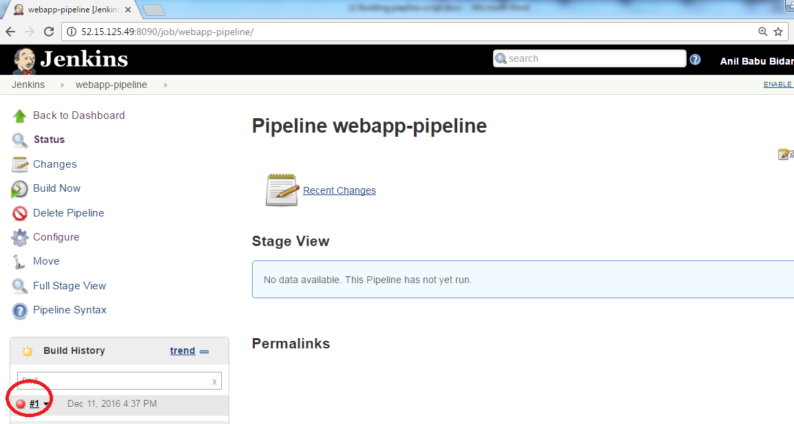

**Next step :** **Click on build #1 console output**

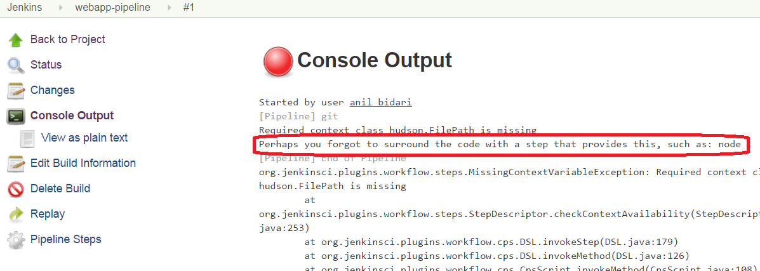

**Next step :** **Got to project and click on configure**

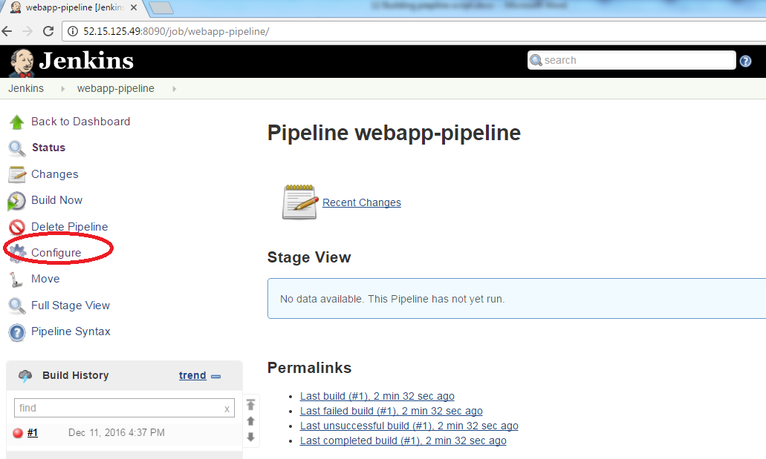

**Next step :** **Add below script and save ,by adding node definition and click save**

node {

git 'https://github.com/anilbidari/https-github.com-g0t4-jenkins2-course-spring-boot.git'

dir('spring-boot-samples/spring-boot-sample-web-static/')

{

sh 'mvn clean package'

archiveArtifacts 'target/*.jar'

sh 'java -jar target/spring-boot-sample-web-static-1.4.0.BUILD-SNAPSHOT.jar'

}

}

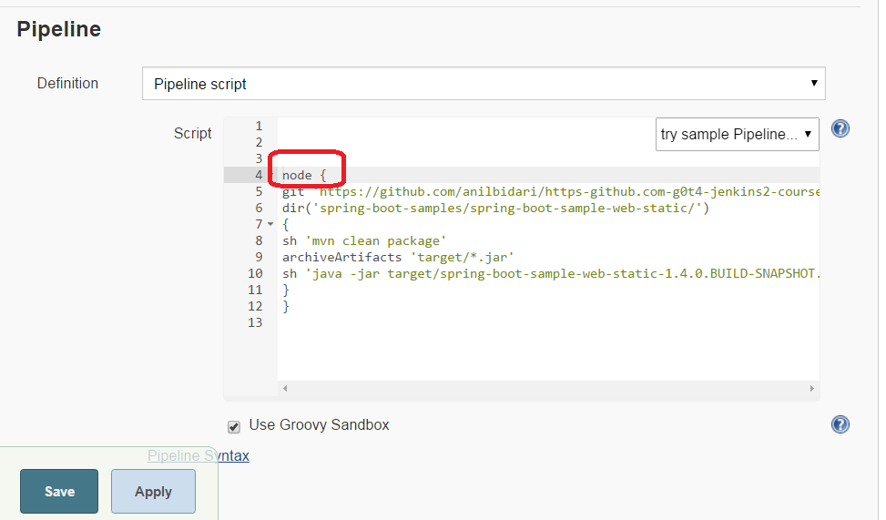

**Next step :** **Click on Build now**



**Next step :** **Artifact should be create by now**

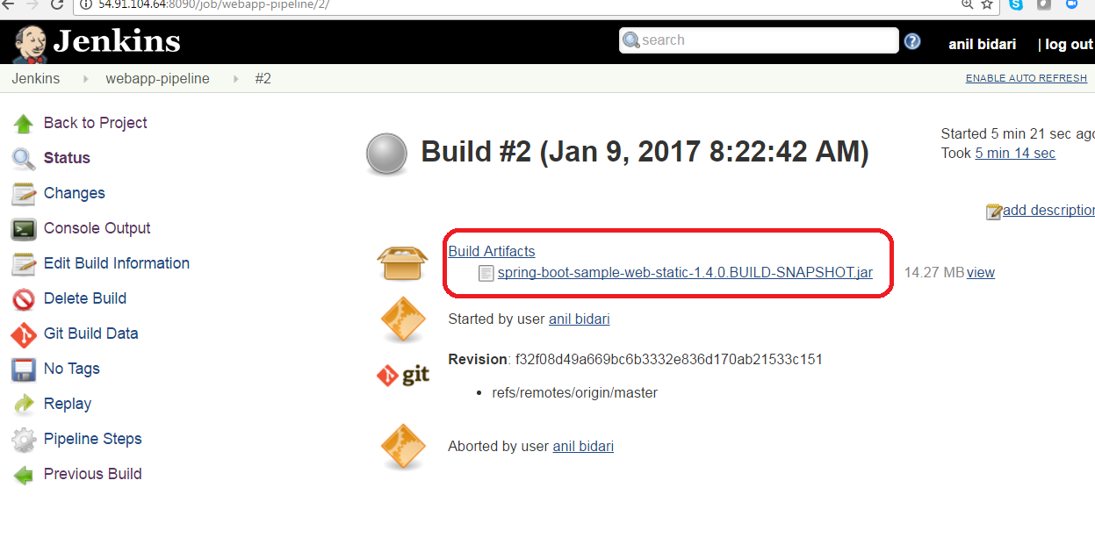

**Validate on web browser the code is that jar is deployed successfully**

http://jenkins-server-ip:8080

